

Fayyoumed



Medical supplies 2019

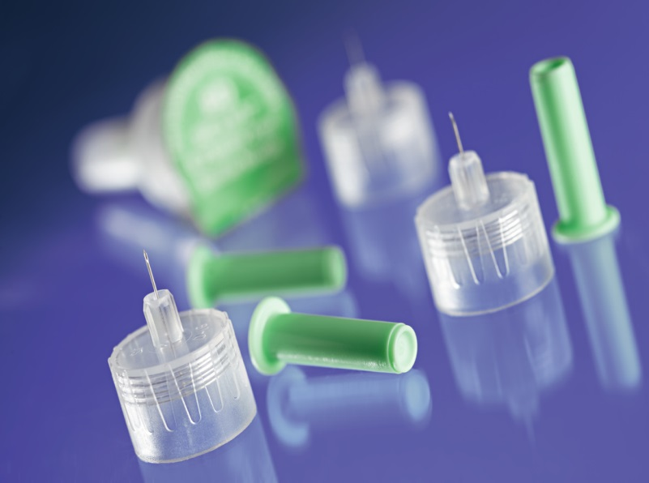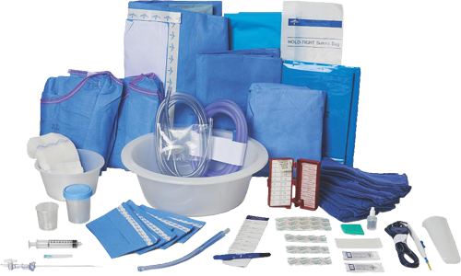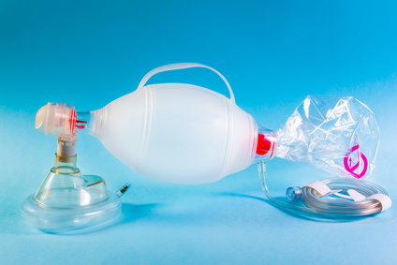

2019

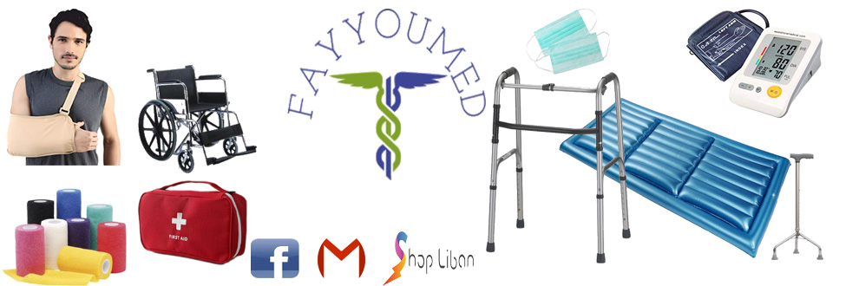

Fayyoumed medical supplies

Mazraa-Barbour-Facing Cocktail dress shop

|  |  |
| --- | --- |
|  | fayyoumed@gmail.com |
|  | /Fayyoumed |
|  | 03-903750 |
|  | /store/fayyoumed |

Contents

Gauzes and cotton

Casting

Cohesive and Elastic Bandages

Syringes and Needles

Gloves

Incontinence and Urological

Briefs and Pads

Respiratory

Diagnostic

Walking Aid

Clinical needs

Solutions

Cushions and seats

Miscellaneous

Orthopedic

Gauzes and Cotton

|  |  |  |  |
| --- | --- | --- | --- |
| ­Gauze Roll 2" 3" 6" | pc |  | 2.00 $  3.34 $  5.34 $ |
| Gauze Roll 36" x 100YD-4Ply | Roll |  | 18.0 $ |
| Gauze sponge 2" x 2" 12 ply | 200/Box |  | 6.00 $ |
| Gauze sponge 2" x 2" 16 ply | 100/Box |  | 3.00 $ |
| Gauze sponge 3" x 3" 12 Ply | 100/Box |  | 3.00 $ |
| Gauze sponge 3" x 3" 16 ply | 100/Box |  | 4.00 $ |
| Gauze sponge 4" x 4" 16 ply | 100/Box |  | 5.34 $ |
| Gauze swab-2" x 2"-sterile 12 Ply | 100/Box |  | 4.70 $ |
| Gauze swab-2" x 2"-sterile 16 Ply | 10/Box |  | 1.34 $ |
| Gauze swab-3" x 3"-sterile 12 Ply | 100/Box |  | 5.34 $ |
| Gauze swab-3" x 3"-sterile 16 Ply | 10/Box |  | 2.00 $ |
| Gauze swab-3" x 3"-sterile 16 Ply | 100/Box |  | 5.00 $ |
| Dressing Roll 10cmx10m | Roll |  | 4.00 $ |
| Cotton Baby buds | 60/Box |  | 1.00 $ |
| Cotton balls | 50/bag |  | 1.00 $ |
| Cotton pads disk-lux-100 | 100/bag |  | 1.34 $ |
| Cotton pads disk-lux-70 | 70/bag |  | 1.00 $ |
| Dental Cotton Ro$-Size 2-Bag | 20/Bag |  | 8.00 $ |
| Gauze swab-4" x 4"-sterile 12 Ply | 100/Box |  | 8.00 $ |
| Transparent Dressing W. Pad 6*7 cm | 25/Box |  | 6.70 $ |
| Transparent Dressing W. Pad 10*12 cm | 25/Box |  | 15.0 $ |
| Transparent Dressing W. Pad 10*20 cm | 50/Box |  | 30.0 $ |
| Transparent Dressing W. Pad 10*25 cm | 25/Box |  | 17.0 $ |
| Cotton tubular stockinet 5 cm x 20m | Roll |  | 10.0 $ |
| Cotton tubular stockinet 10 cm x 20m | Roll |  | 17.0 $ |
| Tracheostomy sponge | 10/bag |  | 10.0 $ |

Casting

|  |  |  |  |  |
| --- | --- | --- | --- | --- |
| Poly Cast- 2" | pc |  | | 2.70 $ |
| Poly Cast- 3" | pc |  | | 3.34 $ |
| Poly Cast- 4" | pc |  | | 4.00 $ |
| Poly Cast- 5" | pc |  | | 4.70 $ |
| Plaster of Paris Bandage  5cmx2.7 m | pc |  | | 1.34 $ |
| Under cast Padding 4" | pc |  | | 1.34 $ |
|  |  |  |  | |
|  |  |  |  | |
|  |  |  |  | |
|  |  |  |  | |
|  |  |  |  | |

Cohesive and Elastic Bandages

|  |  |  |  |
| --- | --- | --- | --- |
| Cohesive Bandage 10cm x 4.5 m | pc |  | 1.70 $ |
| Cohesive Bandage 2.5 cm x 5 m | pc |  | 0.70 $ |
| Cohesive Bandage 5 cm x 4.5 m | pc |  | 1.00 $ |
| Cohesive Bandage 7.5 cm x 4.5 m | pc |  | 2.00 $ |
| Cohesive bandage 8cm x 20m  10 cm x 20m | Roll |  | 4.00 $  5.34 $ |
| Elastic Bandage 5, 7.5, 15 cm | pc |  | 2.00 $  2.34 $  5.34 $ |
| Elastic Bandage 5, 7.5, 10 cm-Flamingo | pc |  | 3.34 $  5.00 $  7.00 $ |
| Band aid | 100/Box |  | 2.00 $ |
| Adhesive Paper Tape 1/2", 1" | pc |  | 0.50 $  0.70 $ |
| Transparent Dressing without pad 5x 7 cm | 25/Box |  | 3.00 $ |

Syringes and Needles

|  |  |  |  |
| --- | --- | --- | --- |
| Disposable needle 18G, 19G,21G,23G,25G,26G,30G | 100/box |  | 3.34 $ |
| Needles Monoject Long & Short | 100/box |  | 6.00 $ |
| Syringes+ needles 20 ml 21G | 50/box |  | 15.0 $ |
| Syringes+ needles 20 ml 21G | 100/box |  | 30.0 $ |
| Syringes+ needles 3 ml | 100/box |  | 5.00 $ |
| Syringes+ needles 5 ml 22G | 100/box |  | 5.34 $ |
| Syringes+ needles 5 ml 23G | 100/box |  | 5.34 $ |
| Bulb irrigation syringe 60 cc | pc |  | 1.34 $ |
| Infusion set 180 cm-Y site | pc |  | 1.34 $ |

Gloves

|  |  |  |  |
| --- | --- | --- | --- |
| Disposable Gloves-Latex-Powdered | 100/box |  | 4.34 $ |
| Disposable Gloves-Nitrile-Powder free | 100/box |  | 5.34 $ |
| Disposable Gloves-Vinyl-Powdered | 100/box |  | 3.70 $ |
| Surgical sterile Gloves | Pair |  | 1.34 $ |
| Latex Gloves- Powdered | 80/box |  | 3.70 $ |
| Cotton Gloves-UV protection | Pair |  | 5.00 $ |

Incontinence and Urological

|  |  |  |  |
| --- | --- | --- | --- |
| Urinal female/Male | pc |  | 3.00 $ |
| Urine cups 60 ml sterile | Pc |  | 0.13 $ |
| Bedpan | pc |  | 4.00 $ |
| Sitz Bath | pc |  | 8.00 $ |
| Vaginal douche | pc |  | 8.00 $ |
| Toilet seat Riser | pc |  | 50.0 $ |
| Shower Chair | pc |  | 40.0 $ |
| Urine Bag 2000 ml | pc |  | 1.34 $ |
|  |  |  |  |
| Foley catheter 2 way-12 FR | Pc |  | 3.00 $ |
| Foley catheter full silicone 2 way-14 FR | Pc |  | 10.0 $ |
| External male catheter | Pc |  | 0.50 $ |

Briefs and Pads

|  |  |  |  |
| --- | --- | --- | --- |
| Adult Diapers Pu$ up | 10/bag |  | 8.70 $ |
| Adult diapers with tape | 10/bag |  | 8.70 $ |
| Under pad 60x40 cm | 30/Bag |  | 8.00 $ |
| Under pad 60x90 cm | 10/bag |  | 8.00 $ |
| Under pad 60x90 cm | 50/bag |  | 13.34 $ |
| Disposable soaped sponge | pc |  | 0.70 $ |
| Bed Cover Water resistant | bag |  | 4.70 $ |
| Bed Cover-Blue | bag |  | 1.34 $ |
| Shoe cover-Blue | 10/bag |  | 1.00 $ |
| Sleeve Cover | 100/Bag |  | 6.00 $ |
| Dental Bibs Paper 33cm X 45cm | 125/Bag |  | 6.00 $ |
| Dental Bibs Paper 53cm X 60cm | 80/Roll |  | 10.0 $ |
| Dental Bibs Paper 33cm X 45cm | 500/Box |  | 25.0 $ |

Respiratory

|  |  |  |  |
| --- | --- | --- | --- |
| Nebulizer GM | pc |  | 65.0 $ |
| Nebulizer PM | pc |  | 55.0 $ |
| Nebulizer Oxygen Mask  Adult/Pediatric | pc |  | 1.70 $ |
| Aero chamber pediatric | pc |  | 10.0 $ |
| Mask for Spacer  Adult/Pediatric | pc |  | 4.00 $ |
| Oxygen Cannula Mask  Adult/Pediatric | pc |  | 1.34 $ |

Diagnostic

|  |  |  |  |
| --- | --- | --- | --- |
| Blood pressure monitor Sejoy-Arm | pc |  | 45.0$ $ |
| Blood pressure monitor Sejoy-Wrist | pc |  | 20.0 $ |
| Blood pressure monitor Yuwell-Arm | pc |  | 30.0 $ |
| Infrared Digital thermometer | pc |  | 12.0 $ |
| Digital thermometer | pc |  | 5.34 $  15.0 $ |
| Oximeter | pc |  | 30.0 $  45.0 $ |
| Sphygmomanometer | pc |  | 15.0 $ |
| Thermometer pacifier | pc |  | 4.00 $ |
| Ear thermometer | pc |  | 20.0 $ |

Walking Aid

|  |  |  |  |
| --- | --- | --- | --- |
| Aluminum walker | pc |  | 30.0 $ |
| Cane tripod | pc |  | 20.0 $ |
| Crutch elbow-Aluminum medium | Pair |  | 20.0 $ |
| Crutch underarm-Aluminum medium | Pair |  | 20.0 $ |
| Wheelchair | pc |  | 120 $  160 $ |
| Cane stick | pc |  | 10.0 $ |
| Walker with seat | pc |  | 40.0 $ |

Clinical needs

|  |  |  |  |
| --- | --- | --- | --- |
| Face Mask 3 Ply Ear loop/Tie on | 50/Box |  | 2.00 $ |
| Paper Mask 1 ply, 7cmx20cm | 100/pkt |  | 2.00 $ |
| Face Visor kit-Disposable Glasses | 12/box |  | 25.0 $ |
| Sterilization Ro$ 10cm x 200m,  25cm x 200m | Ro$ |  | 26.0 $  40.0 $ |
| Protective Glasses | pc |  | 6.70 $ |
| Speculum otoscope 2.75 mm | 34/Bag |  | 6.70 $ |
| Stethoscope | pc |  | 5.00 $ |
| Tongue depressor  Non wrapped/Wrapped | 100/Box |  | 2.00 $  2.70 $ |
| Ultrasound Gel | 500ml |  | 2.70 $ |
| Alcohol Pads | 100/Box |  | 2.00 $ |
| Antiseptic Pads Chlorhexidine2% | 100/Box |  | 3.34 $ |
|  |  |  |  |
| Nasal Speculum 1,2 | pc |  | 30.0$ |
| Disposable ECG electrode | Bag |  | 10.00 $ |
| Paper roll (Bed sheets) 100 M | Roll |  | 7.70 $ |
| ECG 90 mm x 90 mm/400SH | Pkt |  | 4.00 $ |
| Wipes for instruments | pc |  | 10.0 $ |
| Wooden Spatula | 50/Bag |  | 1.00 $ |
| Tourniquet-metal  Plastic | pc |  | 15.0 $  10.0 $ |
| Otoscope Led lamp- M&M | pc |  | 40.0 $ |
| Foot Step | pc |  | 45.0 $ |

|  |  |  |  |
| --- | --- | --- | --- |
| Stethoscope Littmann  Classic III | pc |  | 167 $ |

Solutions

|  |  |  |  |
| --- | --- | --- | --- |
| Antimicrobial Hand rub | 1L  5L |  | 10.0 $  30.0 $ |
| Betadine Solution | 5L/Gallon |  | 23.4 $ |
| Hydrogen Peroxide 10v | 1L  5L |  | 2.00 $  10.0 $ |
| Disinfecting cleaner (ultrasonic cleaner) | 1L |  | 15.0 $ |
| Distilled water | 4L/Gallon |  | 4.00 $ |
| Pure Alcohol 95% | 4L/Gallon |  | 12.0 $ |
| Sterilant for surgical instrument (steroxi) | 1L |  | 15.0 $ |
| Surface disinfectant spray | 1L/Bottle |  | 13.34 $ |
| Antiseptic Spray-  non alcoholic | 100ml/Bottle |  | 8.00 $ |

Cushions and seats

|  |  |  |  |
| --- | --- | --- | --- |
| Wedge pillow-Infant-strain | pc |  | 20.00 $ |
| Wedge pillow Child | pc |  | 20.00 $ |
| Wedge Pillow-Adult | pc |  | 47.0 $ |
| Air Cushion-Rubber | pc |  | 10.0 $ |
| Water mattress | pc |  | 43.4 $ |
| Ring Pillow | pc |  | 30.0 $  25.0 $ |
| Seat wedge Cushion | pc |  | 25.0 $ |
| Cervical memory pillow | pc |  | 30.0 $ |
| Alternating air mattress | pc |  | 50.0 $ |
| Therapeutic air mattress | Pc |  | 170 $ |

|  |  |  |  |
| --- | --- | --- | --- |
| Bibs Holder | pc |  | 4.00 $ |
| Copper T | pc |  | 4.00 $ |
| First Aid Kit | set |  | 10.0 $ |
| Hot water bottle | pc |  | 6.70 $ |
| Ortho Gum brush | pc |  | 5.34 $ |
| Surgical Blade 10 | pc |  | 6.00 $ |
| Suture Nylon 3/O | 12/Box |  | 10.0 $ |
| Tempo Gel  Big/Small | pc |  | 10.0 $  5.00 $ |
| Saliva ejector | 100/Bag |  | 3.34 |
|  |  |  |  |
|  |  |  |  |

Miscellaneous

Orthopedic

|  |  |  |  |
| --- | --- | --- | --- |
| Cervical Orthosis | pc |  | 26.7 $ |
| Cervical Collar with Neck support | pc |  | 20.0 $ |
| Cervical Collar | pc |  | 13.4 $ |
| Soft Collar | pc |  | 10.0 $ |
| Abdominal Belt | pc |  | 20.0 $ |
| Rib Belt Chest | pc |  | 20.0 $ |
| Maternity Belt | pc |  | 20.0 $ |
| Waist Trimmer | pc |  | 20.0 $ |
| Lumbar Corset Belt | pc |  | 26.7 $ |
| Lumbar sacro Belt | pc |  | 26.7 $ |
| Contoured L.S Belt | pc |  | 53.4 $ |
| Posture Brace | pc |  | 26.7 $ |
| Premium Elbow Support | pc |  | 13.4 $ |
| Carpal Tunnel Splint | pc |  | 13.4 $ |
| Knee stabilizer | pc |  | 20.0 $ |
| Heel Cushion Female | pc |  | 16.7 $ |
| Premium Silicone Heel Care Cushion | pc |  | 16.7 $ |
| Premium Silicone Medial Arch Insole | pc |  | 40.0 $ |
| Silicone Foot Insole | pc |  | 33.4 $ |
| Palm Brace | pc |  | 13.4 $ |
| Pediatric Arm Sling | pc |  | 10.0 $ |
| Pelvic Binder | pc |  | 26.7 $ |
| Maternity Back support | pc |  | 8.00 $ |
| Maternity Belt | pc |  | 20.0 $ |
| Maternity Belt breathable | pc |  | 10.0 $ |
| Cast Shoe | pc |  | 20.0 $ |
| Anklet | pc |  | 13.7 $ |
| Anklet Premium | Pc |  | 16.7 $ |
| Ankle Brace | pc |  | 20.0 $ |
| Arm Pouch | Pc |  | 10.0 $ |
| Wrist Cock-up splint | pc |  | 16.7 $ |
| Thumb Spica Splint | Pc |  | 10.0 $ |
| Cot Splint | Pc |  | 6.70 $ |
| Spoon Splint | Pc |  | 6.70 $ |
| Premium varicose vein stockings | Pc |  | 40.0 $ |
| Premium below knee stockings | Pair |  | 27.0 $ |
| Ankle support | pc |  | 8.00 $ |
| Shoulder support | Pc |  | 26.7 $ |
| Toe straightener | Pc |  | 10.0 $ |
| Exercise Cycle-no counter  With Counter | Pc |  | 50.0 $  60.0 $ |
| Clavicle brace | Pc |  | 20.0 $ |
| Air traction Back pain | Pc |  | 124 $ |
| Neck Tractor type A | Pc |  | 50.0 $ |
| Neck Tractor type B,C | Pc |  | 40.0 $ |
| Anti-embolism stockings  below knee | Pair |  | 20.0 $ |
| Anti-embolism stockings  above knee | Pair |  | 33.4 $ |
| Corset Umbilical Hernia | Pc |  | 20.0 $ |
| Stress Ball soft, medium and hard | Pc |  | 10.0 $ |
|  |  |  |  |